12/11/24
THM 415: Finance
Midterm Exam
- “In the case of bankruptcy, common stockholders are paid before preferred stockholders”. Do you agree with this order? Why? Why not? (2 Points)
I don’t agree with this statement. In the face of bankruptcy, common stockholders are paid after preferred stockholders (if money remains!). The main reason is that, since common stockholders have the right to vote, and, hence, elect board of directors who will, in turn, assign, senior management, they are indirectly responsible for the worsened situation of the corporation (bankruptcy in this case). Therefore, they shall be penalized as to get their money back (if any) after all debtholders and preferred stockholders are paid.
- Silva Hotel had recorded the following income statement accounts sorted in alphabetical order:
Cost of Goods Sold | $256,450
Interest Expenses | $63,231
Operating Expenses | $187,523
Sales | $1,903,000
In addition, since Silva Hotel owns 37 % shares of Rafa Company, it is entitled to $ 243,243 of dividends income from that very company. Moreover, Silva hotel’s board of directors decided to distribute $ 375,000 as dividends to their shareholders.
The following table reveals Income Tax Rates for Corporate Income for 2023 fiscal year:
Taxable Income | Marginal Tax Rate
$ 0 – $ 50,000 | 12%
$ 50,001 - $ 75,000 | 14%
$ 75,001 - $ 100,000 | 16%
$ 100,001 - $ 250,000 | 18%
$ 250,001 - $ 350,000 | 20%
$ 350,001 - $ 750,000 | 22%
Over $ 750,000 | 28%
Lastly, the following table shows dividend income exclusion to avoid double taxation at corporate level.
Ownership Interest | Dividend Exclusion
Less than 15 % | 23%
15 % to 30 % | 33%
30 % to 60 % | 43%
60 % to 70 % | 53%
70 % to 80 % | 63%
More than 80 % | 100%
a) Construct Silva Hotel Income Statement for the year ended December 31st, 2023. (2 Points)
Moreover, the following is Silva Hotel’s comparative balance sheet as of December 31st, 2022 and December 31st, 2023:
- Construct Silva Hotel Statement of Cash Flow for the year ended December 31st, 2023. (3 Points)
- Calculate the Quality of Earnings. Interpret your result. (1 Point)
- Quality of Earnings = (Cash Flow from Operations) / (Net Income) = 1,104,826 / 1,027,652 = 107.51 %.
Thus, in 2023, Silva Hotel’s cash flow from operations was 107.51 % of the firm’s reported net income.
- Calculate the Capital Acquisition Ratio. Interpret your result. (1 Point)
- Capital Acquisition Ratio = (Cash Flow from Operations) / (Cash Paid for Capital Expenditures) = 1,104,826 / 138,128 = 799.86 %.
Thus, in 2023, Silva Hotel generated, from its operations, cash flow that is able to finance nearly 8 times of its new expenditures for plant and equipment.
- Based on the income statement prepared in part a), comparative balance sheet and cash flow statement prepared in part b), analyze the financial situation of Silva Hotel for the fiscal year 2023. (3 Points)
Income Statement:
- In 2023, Silva hotel is a profitable company as its revenues (i.e. sales) are greater than its costs.
- In 2023, Silva Hotel’s mark-up on its cost of goods sold is 86.52 %.
- In 2023, for each dollar of revenue, Silva Hotel is left with 76.67 cents after deducting all its operating expenses.
- In 2023, each one dollar of sales is associated with 54 cents of net income.
Balance Sheet:
- Silva hotel is a highly liquid company as its net working capital is $ 652,179. This means that current assets can shrink by as much as $ 652,179 and the company would still be able to pay its current liabilities.
- In Silva Hotel, the purchases of assets are financed 46.04 % through debt and 53.96 % through equity.
- For each one dollar of net income, 63.51 cents are retained in the business.
Statement of Cash Flow:
Cash flow from operating activities:
- Silva Hotel has positive cash flow from operating activities.
- The primary contributors to the operating cash flows were net income, inventories and depreciation expense.
- Accounts receivables and accounts payable are the contributors of cash usage.
Cash flow from investing activities:
- Silva Hotel invested $ 138,128 in purchasing fixed assets. This represents 12.50 % of the total cash flow generated from operations.
Cash flow from financing activities:
- Silva Hotel has negative cash flow from financing activities.
- Cash usage resulted from payment of already declared dividends, purchase of already issued common stocks, payment of long-term debts as well as purchase of marketable securities.
- The contributors to cash were the value market price gain of common stocks and obtention od short-term loan.
- Suppose you would like to double your investment. For this purpose, you deposited in a bank $ 21,888.12 to be compounded monthly at an interest rate of 7.03 %. Calculate the period (in years) needed to reach your objective? (1 Point)
- Interest Rate = 7.03 % / 12 ≈ 0.5858333 %; Present Value = - $ 21,888.12; Payment = $0; Future Value = $ 43,776.24.
Answer: Nper (0.5858333 %, 0, -21888.12, 43776.24) / 12 = 9.89 Years.
Therefore, it would take 9.89 years for an investment of $ 21,888.12 to double at an annual interest rate of 7.03 % compounded monthly.
- After examining the various interest rates opportunities, you find that you can borrow from a finance company at 8.17 % compounded monthly, from bank A at 8.15 % compounded weekly.
a) Which alternative is the most attractive? Why? (1 Point)
- Borrowing from Finance Company: Effective Annual Rate= Effect (8.17 %, 12) = 8.48 %.
- Borrowing from bank A: Effective Annual Rate = Effect (8.15 %, 52) = 8.48 %.
Since I am borrowing, I shall choose the offer that has the lowest Effective Annual Rate. Therefore, I shall borrow from Finance Company (8.4830 % for Finance Company A vs. 8.4844 % for Bank A).

b) If you wanted to consider Bank B which offers continuous compounding. What is the maximum interest rate suggested by this very bank to start thinking about the offer? (1 Point)
Bank B shall give me a maximum rate of 8.14 % to start thinking about the offer.
- Immobile wanted to buy a home that costs $ 400,000. He took a 10-year mortgage loan with semi-annual payments at an annual rate of 5.12 %.
a) How much will Immobile pay each period? (1 Point)
Interest = 5.12 % / 2 = 2.56 %, Period = 10 * 2 = 20; Present Value = $ 400,000; Future Value = $ 0
Answer: Payment (256 %, 20, 400000, 0) = - $ 25,804.50.
b) Fill in the amortization schedule. (3 Points)
Period | Amount Owed on the Principal (Beg. Period) ($) | Annuity Payment ($) | Interest Portion of the Annuity ($) | Repayment of the Principal Portion of the Annuity ($) | Outstanding Loan Balance ($)
1 | $400,000.00 | $25,804.50 | $10,240.00 | $15,564.50 | $384,435.50
2 | $384,435.50 | $25,804.50 | $9,841.55 | $15,962.95 | $368,472.54
3 | $368,472.54 | $25,804.50 | $9,432.90 | $16,371.61 | $352,100.94
4 | $352,100.94 | $25,804.50 | $9,013.78 | $16,790.72 | $335,310.22
5 | $335,310.22 | $25,804.50 | $8,583.94 | $17,220.56 | $318,089.66
6 | $318,089.66 | $25,804.50 | $8,143.10 | $17,661.41 | $300,428.25
7 | $300,428.25 | $25,804.50 | $7,690.96 | $18,113.54 | $282,314.71
8 | $282,314.71 | $25,804.50 | $7,227.26 | $18,577.25 | $263,737.46
9 | $263,737.46 | $25,804.50 | $6,751.68 | $19,052.82 | $244,684.64
10 | $244,684.64 | $25,804.50 | $6,263.93 | $19,540.58 | $225,144.06
11 | $225,144.06 | $25,804.50 | $5,763.69 | $20,040.81 | $205,103.25
12 | $205,103.25 | $25,804.50 | $5,250.64 | $20,553.86 | $184,549.39
13 | $184,549.39 | $25,804.50 | $4,724.46 | $21,080.04 | $163,469.35
14 | $163,469.35 | $25,804.50 | $4,184.82 | $21,619.69 | $141,849.66
15 | $141,849.66 | $25,804.50 | $3,631.35 | $22,173.15 | $119,676.51
16 | $119,676.51 | $25,804.50 | $3,063.72 | $22,740.78 | $96,935.73
17 | $96,935.73 | $25,804.50 | $2,481.55 | $23,322.95 | $73,612.78
18 | $73,612.78 | $25,804.50 | $1,884.49 | $23,920.02 | $49,692.76
19 | $49,692.76 | $25,804.50 | $1,272.13 | $24,532.37 | $25,160.40
20 | $25,160.40 | $25,804.50 | $644.11 | $25,160.40 | $0.00
c) Suppose that exactly after 4 years, mortgage interest rates fell to 4.04 %. If Immobile has the chance to refinance his loan at that very interest, how much would he pay (on a semi-annual basis) for the remaining 6 years of the loan? (1 Point)
Interest = 4.04 % / 2 = 2.02 %, Period = 6 * 2 = 12; Present Value = $ 263,737.46; Future Value = $ 0
Answer: Payment (2.02 %, 12, 263737.46, 0) = - $ 24,969.55.
d) If such a refinance opportunity is associated with paying a prepayment penalty fee to the bank of $ 9,000, shall Immobile refinance his loan? Why? Why not? (2 Points)
The answer to this question lies in coming up with cash flow increments by taking the difference of cash flows (for each of the remaining 6 years) between the first scenario (i.e. continuing paying $ 25,804.50) and second scenario (i.e. paying $ 9,000 as a penalty in year 0, and saving $ 834.95 for the remaining 12 six-month period). To sum up, the following table reveals the cash flow increments from opting for the second scenario:
As can be seen from the above table, paying $ 9,000 as a pre-payment penalty but start saving $ 834.95 for the remaining 12 six-month period (i.e. 25,804.50 – 24,969.55) would yield a negative return. Hence, Immobile shall not re-finance the mortgage loan since he will be worse off when opting for the second scenario.
- Upon evaluation of the distribution of returns of Felix company, the following possible rate of returns for the upcoming period as long as their probability of occurrence are estimated:
Probability of Occurrence | Rate of Return on Investment
10% | -10.53%
12% | -4.13%
14% | -2.56%
20% | 3.14%
18% | 5.25%
16% | 7.89%
10% | 14.14%
a) Calculate the Expected Rate of Return of Felix Company stock. (1 Point)
- Expected Rate of Return = (10 % * - 10.53 %) + (12 % * - 4.13 %) + (14 % * - 2.56 %) + (20 % * 3.14 %) + (18 % * 5.25 %) + (16 % * 7.89 %) + (10 % * 14.14 %) = 2.34 %.
b) What is the risk of the investment in Felix Company stock as measured using the standard deviation of possible future rates of return? (2 Points)
- Cher bought some stocks of Ndour Company worth of 575,000 Euros 8 years ago. Following is the beginning value of Cher bought stocks 8 years ago as well as the values at the end of each year up until today (the end of year 8):

Year | Stock Value (Euros)
0 | 575,000.00
1 | 544,927.50
2 | 533,266.05
3 | 550,010.61
4 | 574,926.09
5 | 621,840.05
6 | 640,433.07
7 | 682,893.78
8 | 676,884.32
a) What will be the annual rate of return that Cher expects to earn next year, if he plans to continue holding Ndour Company stocks? (1 Point)
- Annual rate of return that Cher expects to earn next year, if he plans to continue holding Ndour Company stocks = (- 5.23 % - 2.14 % + 3.14 % + 4.53 % + 8.16 % + 2.99 % + 6.63 % - 0.88 %) / 8 = 2.15 %.
b) What annual rate of return that Cher expects over a six-year horizon from holding Ndour Company stocks? (1 Point)
- Annual rate of return that Cher expects over a six-year horizon from holding Ndour Company stocks = ((1 + 3.14 %) * (1 + 4.53 %) * (1 + 8.16 %) * (1 + 2.99 %) * (1 + 6.63 %) * (1 - 0.88 %)^^{(1/6)}) – 1) = 4.05 %.
- You own a portfolio consisting of the following stocks:
Stock | Portfolio Allocation | Beta | Expected Rate of Return
1 | 21.00% | 0.85 | 10.88%
2 | 28.00% | 0.93 | 12.03%
3 | 14.00% | 1.11 | 18.44%
4 | 17.00% | 0.78 | 11.53%
5 | 20.00% | 1.04 | 14.76%
Assume the risk-free rate is 5.56% and the expected return on the market portfolio is 12.75 %.
- Calculate the expected return of your portfolio. (0.50 Points)
- Expected return (Portfolio) = (21 % * 10.88 %) + (28 % * 12.03 %) + (14 % * 18.44 %) + (17 % * 11.53 %) + (20 % * 14.76 %) = 13.15 %.
- Calculate the portfolio beta. (0.50 Points)
- Beta (Portfolio) = (21 % * 0.85) + (28 % * 0.93) + (14 % * 1.11) + (17 % * 0.78) + (20 % * 1.04) = 0.93.
- Plot the security market line on a graph. (2 Points)
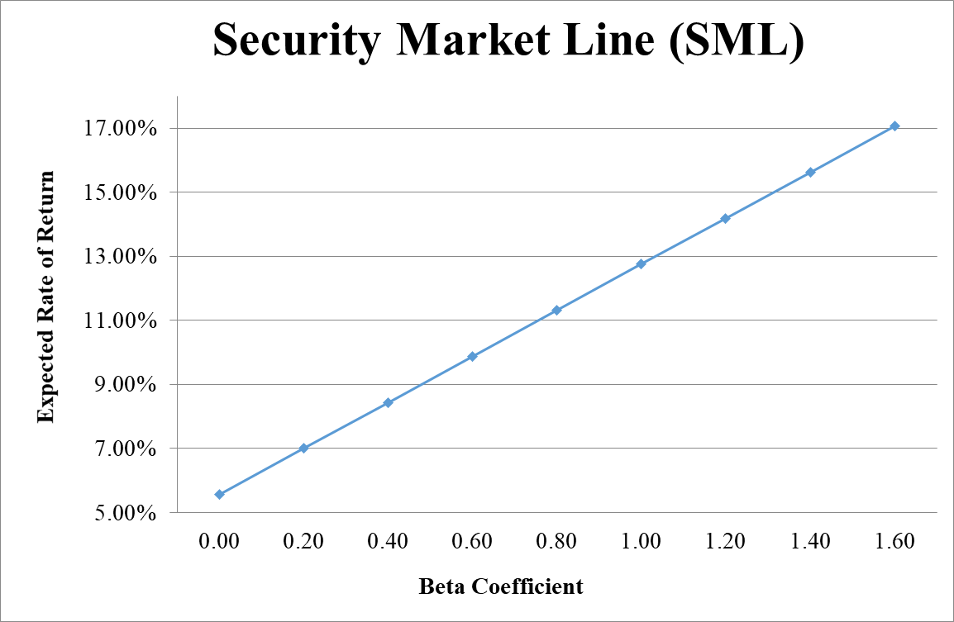

- From your plot in part c, which stocks appear to be your winners, and which ones appear to be losers? Explain the reason behind your conclusion. (2 Points)
- Logic → If Expected Return < SML Expected Return → Loser, otherwise Winner.
- Why should you consider your conclusion in part d) to be less than certain? (1 Point)
This conclusion is based on our having the right betas. Recall that calculation of Betas is subjective (i.e. depend on the market to be chosen, sample size, time interval chosen, definition of period…). If all of our betas understate their stock’s systematic risks, then we would be underestimating our portfolio risk.

GOOD LUCK!

